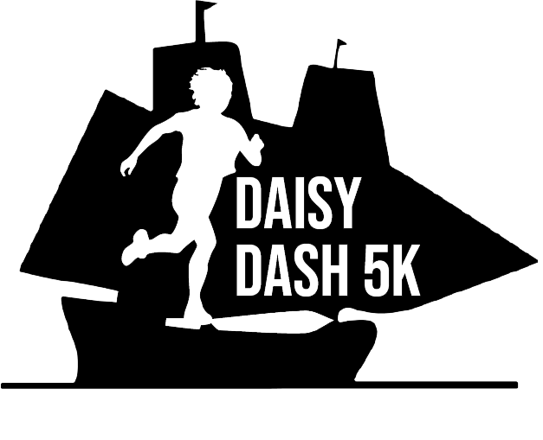
Run, Walk & Kids Fun Run
Saturday, MARCH 25, 2023

Dear Potential Sponsor,

We are thrilled to be planning our 10th annual 5k run at Daisy Ingraham Elementary School in Westbrook. This year our race will be held in person on Saturday, March 25th. On behalf of the Daisy Ingraham PTO and the race committee, we are inviting YOU to consider supporting our event. Our 2019 race was our most successful and we will strive to exceed that this year! The Daisy Dash will be an exciting run/walk which will begin at Daisy Ingraham Elementary School, proceed to scenic Seaside Avenue, then run along the Westbrook Beach before looping back to Daisy. This event brings the community together to celebrate health, wellness and friendly competition!

Daisy Ingraham’s PTO is a nonprofit service organization. All proceeds benefit the PTO to help provide teacher resources and learning opportunities for our students. Recently, the Daisy Ingraham PTO was able to purchase a climbing wall for the Daisy Ingraham students! You may contribute to our event in a number of ways (all tax-deductible). By supporting this event, your company can benefit from having your name and logo displayed on banners, signs, website and t-shirts; as well as strengthening your business’s exposure to our community and being on site for race day.

Another way to support the Daisy Dash 5k is to make a donation. One of our post-race highlights will include awarding prizes to our runners in the form of gift cards. Additionally, we welcome various food donations for our race participants.

Attached, please find two forms. The first is a sponsorship form with various levels to choose from. The second is our donor form if you would prefer to donate a gift card or food item.

The Daisy Dash 5k is our largest fundraiser of the year and many of our programs depend on its success. We thank you in advance for considering supporting our children and teachers at Daisy Ingraham Elementary School. If you have any questions please email us at info@daisydash5k.com, visit our website at www.daisydash5k.com or visit us on Facebook: @DaisyIngrahamPTO.

Appreciatively,
Daisy Dash 5k Race Committee

Please make a copy of your form (Sponsor or Donor) for your records. Daisy PTO is a nonprofit 501(c)(3) corporation.
No goods or services were provided in exchange for this donation. Federal ID: 06-1303428

Run, Walk & Kids Fun Run
Saturday, MARCH 25, 2023

Sponsorship Form
All proceeds benefit the PTO and provide enrichment learning opportunities for Daisy Ingraham students!

Sponsorship Levels:

Premier Sponsor: $1000 +
- Your business name and LARGE logo featured prominently on ALL promotional material, advertising, race t-shirts, event banner, your website link on DaisyDash5k.com and all social media promotions
- Three free race registrations
- Prime placement sponsor booth at event

Start/Finish Line Sponsor: $750
- Your business name and logo listed on start or finish line banner, LARGE logo on race t-shirt and your website link on DaisyDash5k.com
- Two free race registrations
- Sponsor booth at event

Mile Marker/Hydration Sponsors: $500
- Your business logo featured on a mile marker or water stop sign, race t-shirt and your website link on DaisyDash5k.com
- One free race registration
- Sponsor booth at event

Motivational Sponsor: $200
- Your business name featured on race t-shirt and your website link on DaisyDash5k.com
- Sponsor booth at event

PLEASE MAKE CHECKS PAYABLE TO: Westbrook PTO
REMIT TO: Westbrook PTO, Daisy Ingraham Elementary, 105 Goodspeed Drive, Westbrook, CT 06498
RETURN PAYMENT & COMPLETED SPONSOR FORM BY March 1, 2023 to ensure sponsor logo on promotional materials.

Sponsor Name: _____________________________________________________________________________Telephone: ______________________________________

Business/Company: _______________________________________________________________________ Email: ____________________________________________
(As to appear on t-shirt and promotional material)

Address: ______________________________________________________ City: _____________________________ State: ______________ Zip: __________________

Donation Amount: _________________________ Contact Signature: ____________________________________________________ Date: ________________

Run, Walk & Kids Fun Run
Saturday, MARCH 25, 2023

Donation Form
All proceeds benefit the PTO and provide enrichment learning opportunities for Daisy Ingraham students!

Please complete the following donor information:

Donor Name: ______________________________________________________ Telephone: ____________________________

Business/Company: _______________________________________________ Email: __________________________________

Address: _____________________________________________________ City: ________________ State: _____ Zip: __________

Contact Signature: _________________________________________________ Date: ___________________________________

Donation Information:

______ Gift Certificate/Cards

______ Food items for runners

______ Other

Approximate Retail Value $ _______________ Description of item: __________________________________________

All donors recognized on race day!

PLEASE MAKE CHECKS PAYABLE TO: Westbrook PTO
REMIT TO: Westbrook PTO, Daisy Ingraham Elementary, 105 Goodspeed Drive, Westbrook, CT 06498
RETURN PAYMENT & COMPLETED SPONSOR FORM BY March 1, 2023 to ensure sponsor logo on promotional materials.

